Crocs in the Classroom

Congratulations on entering an entirely new realm of wildlife education with our ‘Croc in the Classroom’ project. Please take a few minutes and read through these materials so that you will be prepared to care for your new animal. The species you are receiving is a spectacled caiman (Caiman crocodilus). Attached you will find a synopsis of this animal’s natural history, current range, and status. The remainder of your packet is your loan agreement for the animal, care information, and a few ideas for starting your class project.
We look forward to helping you with any questions you may have about the project as well as any animal questions you may develop during the project. At the conclusion of the school year we will schedule a date to pick up your animal so that you may enjoy your summer. Feel free to contact me directly with the information listed below.

Sincerely,
Chris Dieter
Owner/Crocodile Encounter
crocodileencounter@gmail.com
281.595.2232

Crocs in the Classroom Caresheet

When properly cared for young crocodilians are incredibly resistant to harm. What follows is information you can use to properly set up your animal so that its stress level is low and so is yours!

Basic housing:
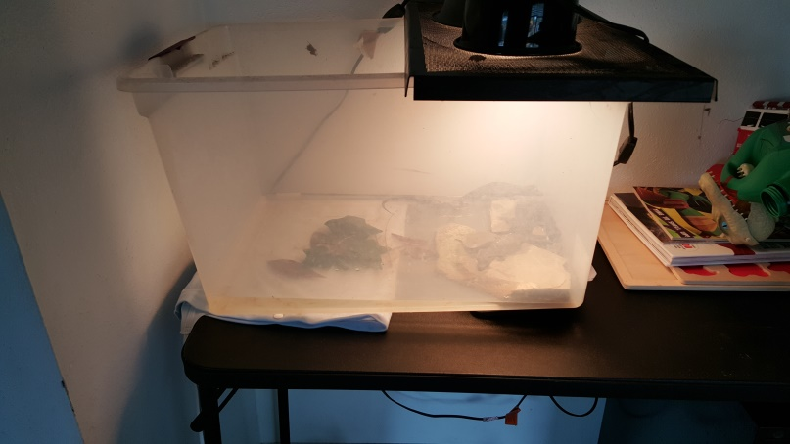

Your crocodilian will be small enough to fit in the palm of your hand. No vertebrate animal grows more during its lifetime proportionaly than a crocodilian. At this size through the first year of its life, your caiman will be able to be housed in a suitably size Rubbermaid tub or aquarium. The tubs have advantages because they are much lighter and therefore easier to move and clean. Water changes should be done at least weekly. However, if you choose to add filtration (low water filters are available at Petsmart in the reptile section for turtles) the water change interval can be lengthened until the water quality becomes substandard. Tap water is fine for your crocodilian.

Step 1: Put your enclosure on a slant.( This will give your caiman a varied water depth) A one inch rise will be sufficient for the start of the project.
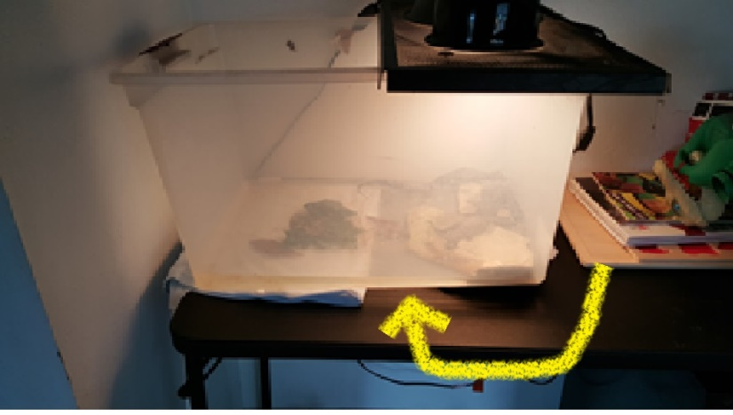
Step 2: On the low side add a basking rock that will be positioned under the overhead light.
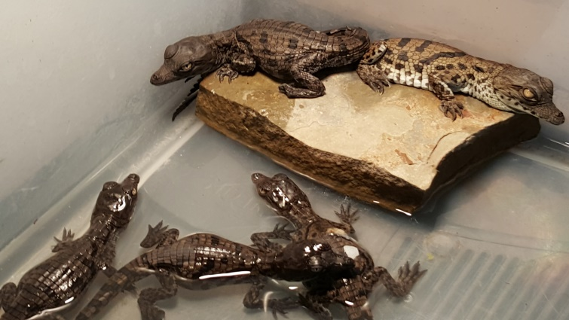
Step 3: Add an artificial plant leaf or twig in the deeper end.
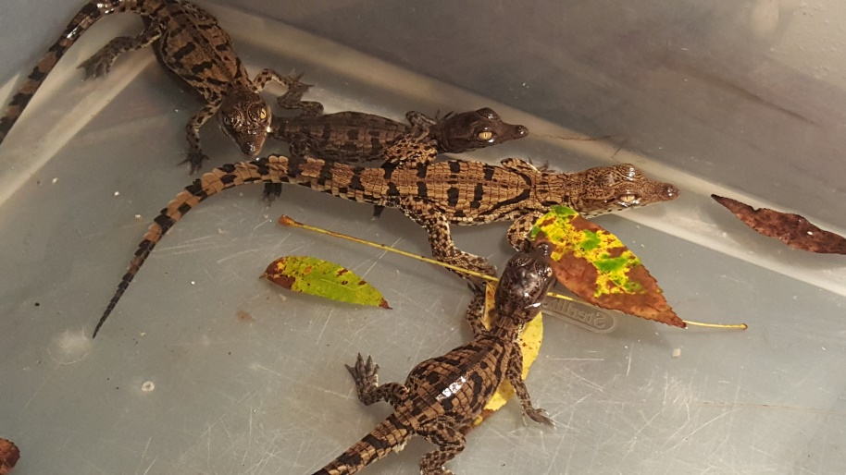

Step 4: Add your lights. If you’re using an aquarium you can place them directly on the screen cover pointing down over your basking rock. If you’re using a Rubbermaid you may have to cut a portion of the top out and affix a screen to hold your light. The proper light is a spot light with a high number of lumens. The lumens will give you the appropriate basking temperature. Make sure to use a ceramic top on your lamp as the lights can get quite warm. You want a basking temperature on the rock to be between 85-100F consistently. The warming of the rock will also warm the water temperature as well.
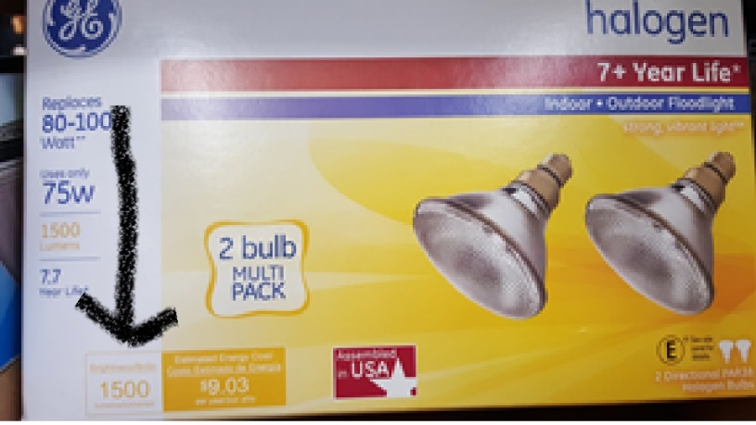
High Lumens (1500)
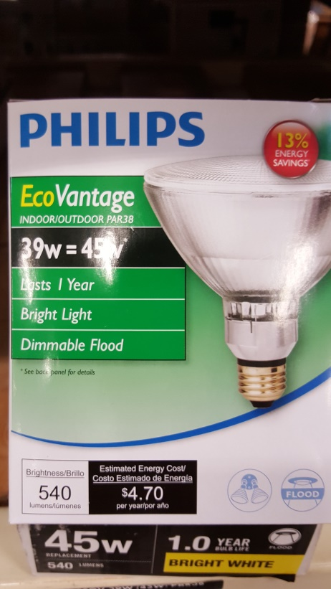
Low Lumens (540)
Proper Diet
You may use any of the following for your crocodilian:
- Pelleted diet
- Fish
- Crickets
- Chopped mice
As a general rule, unless you’re doing a classroom demonstration, the pelleted diet is your best and most convenient option. We will provide you a starter supply of the diet. During the project you are always free to come to our facility or the central office building to acquire more. You may also pick up the following diet at Petsmart for variety as it is also a good choice.
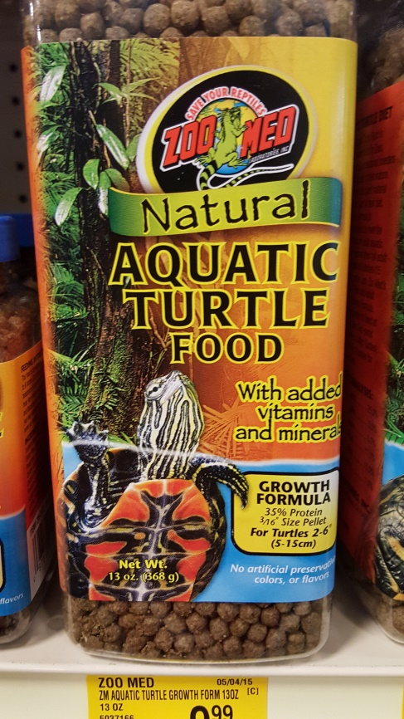

Feed your crocodilian 2-5 pellets a day initially. If you see pellets being left uneaten or all the pellets consumed quickly adjust the amount you feed the animal. There is variance between animals just like people and your animal is unique. Feed accordingly! There is no need to feed the caiman over the weekends.
Handling and Safety

- Your young caiman is very safe around you and your students. They can cause nothing more than a nip at this size and will rarely bite at all.

- The great danger in a classroom is to the animal from the students. Interaction should be limited to observation, feeding, and teacher led measuring and weighing biweekly or monthly.

- For smaller animals, especially hatchlings, it's better to try and lift the animal carefully from underneath, and restrain it gently within the palm of one hand. Placing a thumb over a rear leg or the base of the tail will help to restrain it without restricting all movements. If the animal is trying to bite, placing a gentle grip over the shoulders and neck with the forefinger and thumb is enough to prevent the head from turning and biting you. When picking up a hatchling, there is often little need to "pounce" on it like a cat, which will only serve to stress your hatchling.

- In the time you have the caiman it will not grow to a dangerous size. At most you will see a 12 inch or so caiman with most being much smaller than that size.

- Make sure you have a lid on the animal at all times with the exception of cleaning, feeding, and measurement.

Interactive ideas with your crocodilian – real science ahead!

Your students will immediately benefit from having your crocodilian in your classroom. The setting up and establishment of your own personal swamp is both a fun and exciting time for you and your students. Establishing the habitat’s proper temperature gradient, features, and water levels will help your students understand the interactions that occur in nature every day that enable these keystone species to succeed in their environment.
We highly encourage you to make a yearlong study of your crocodilians growth. They are easy to weigh and measure and having the students follow the animals growth throughout the year is a great way to keep your students involved and motivated in the classroom. Keep a chart that records his mass and length as well as the total number of feedings and food items eaten each month.
